Portfolio
Max Auerbacher
Please enjoy this temporary portfolio document as I rework my website.
As of 2024-04-13.
If you are reading this I am working on this document right now.
Hello Fred Foster Mentorship folks! This is for you.
Artaud, Artaud – Lighting Design – SUNY New Paltz
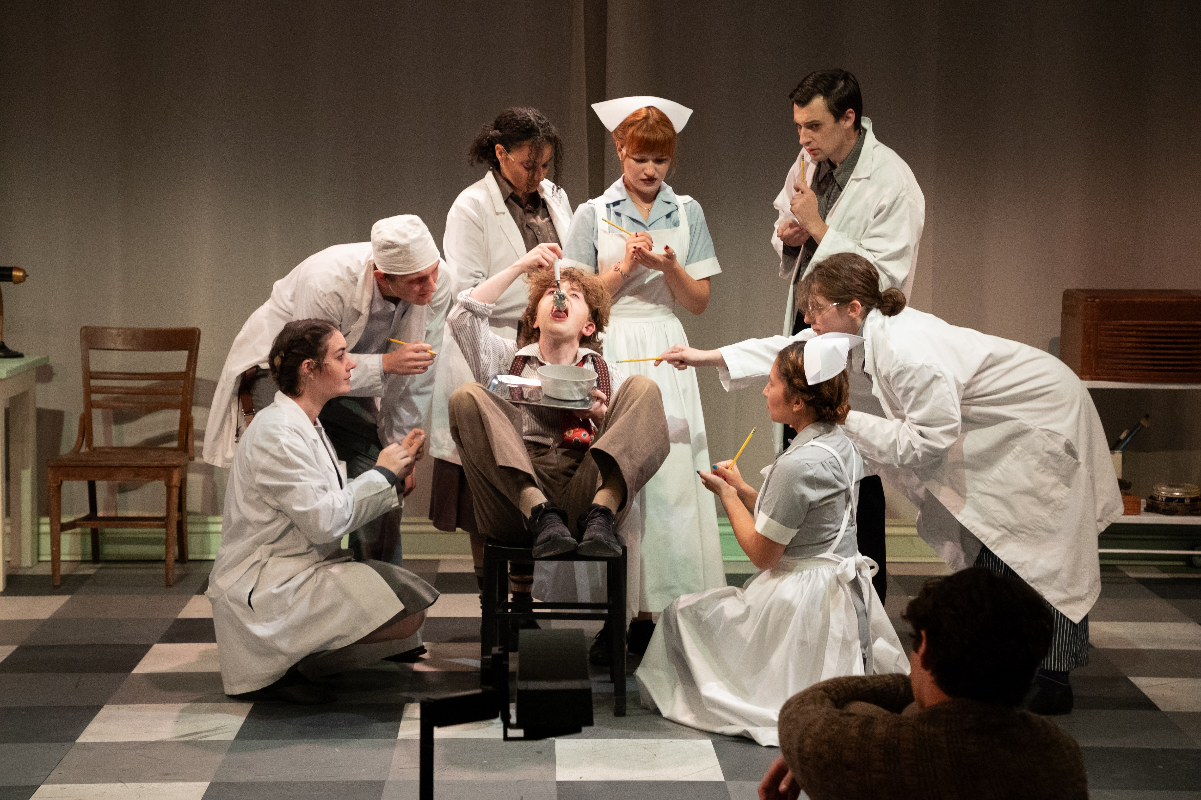
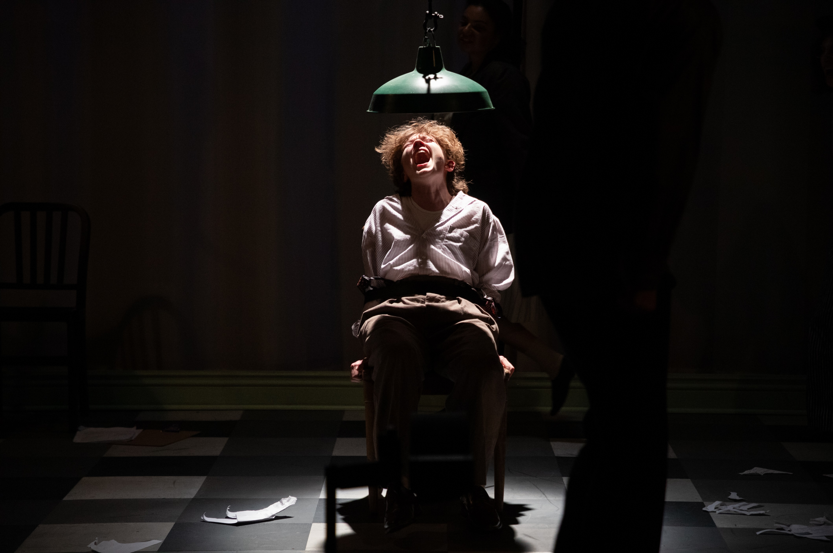
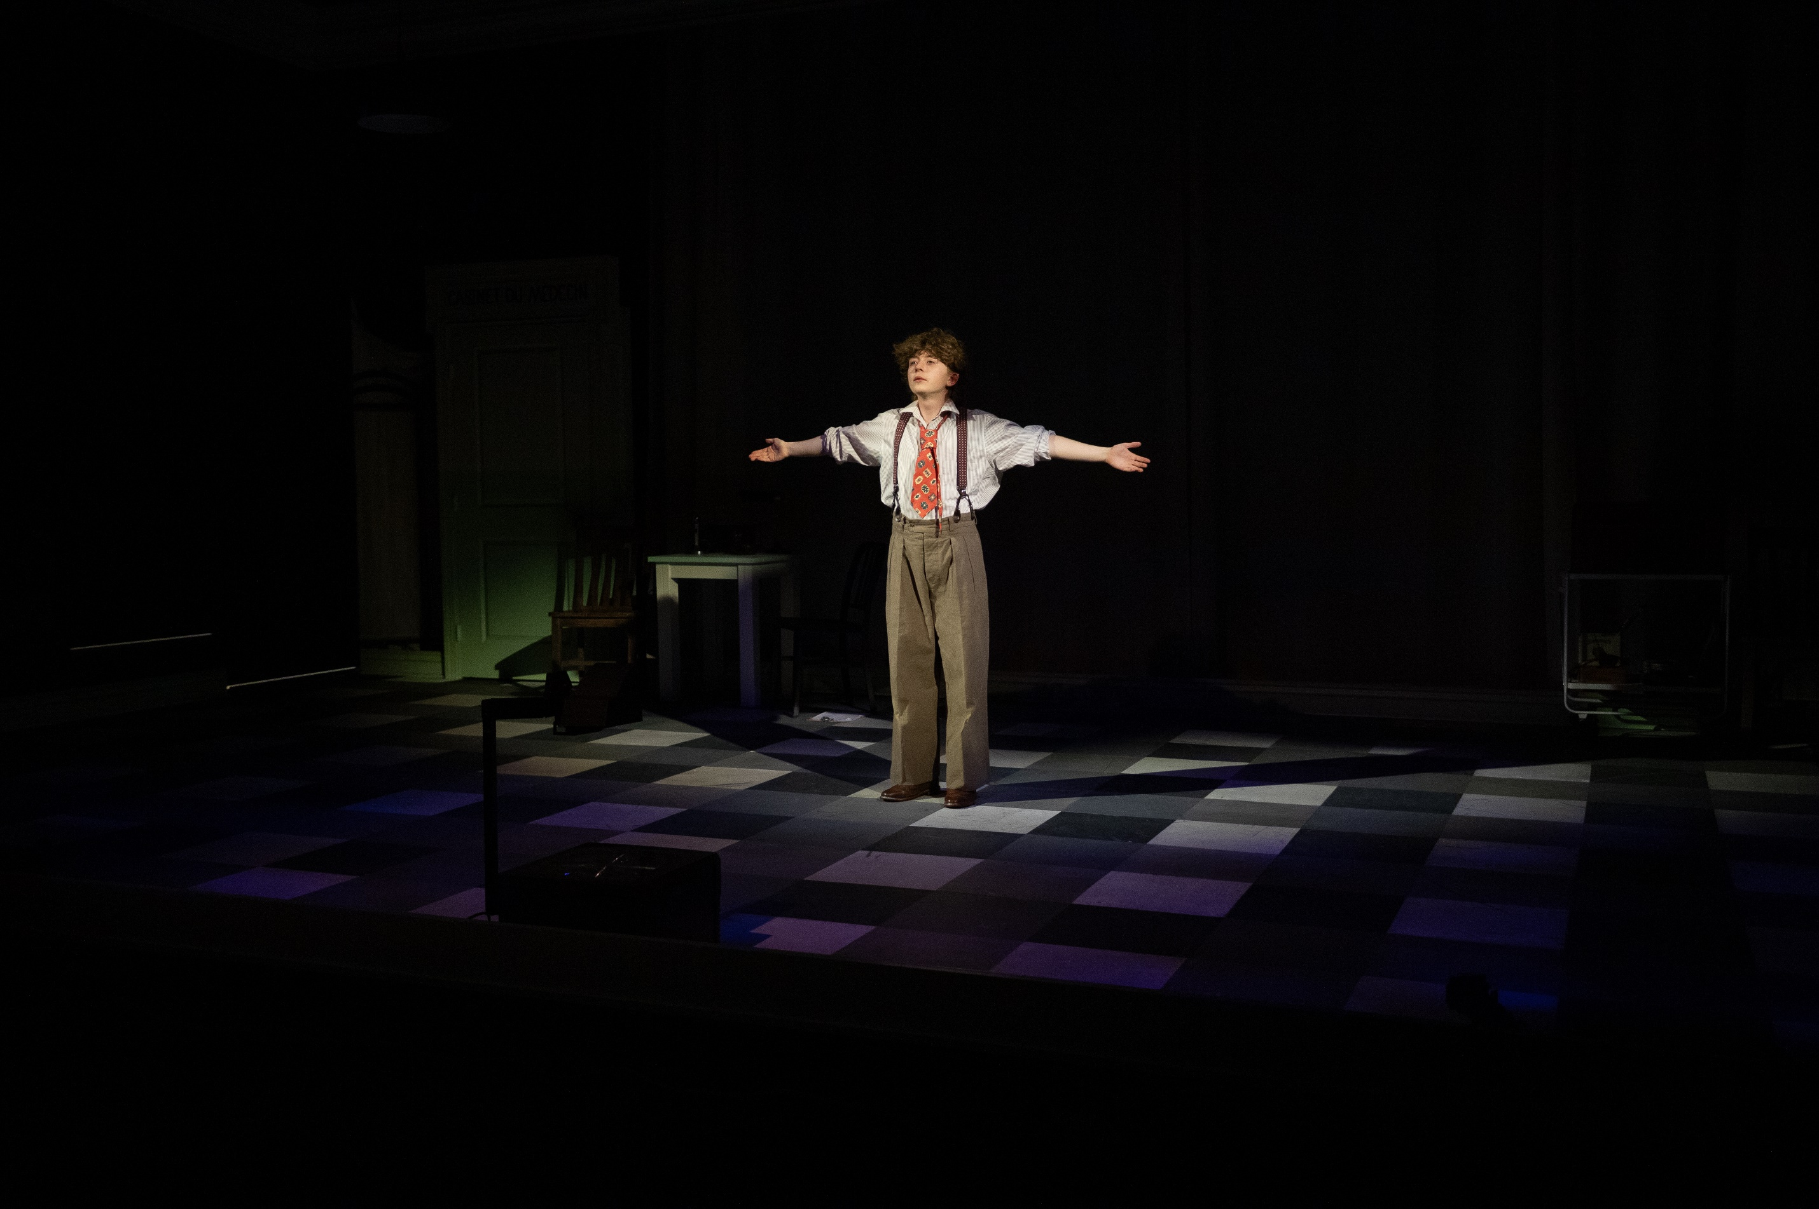
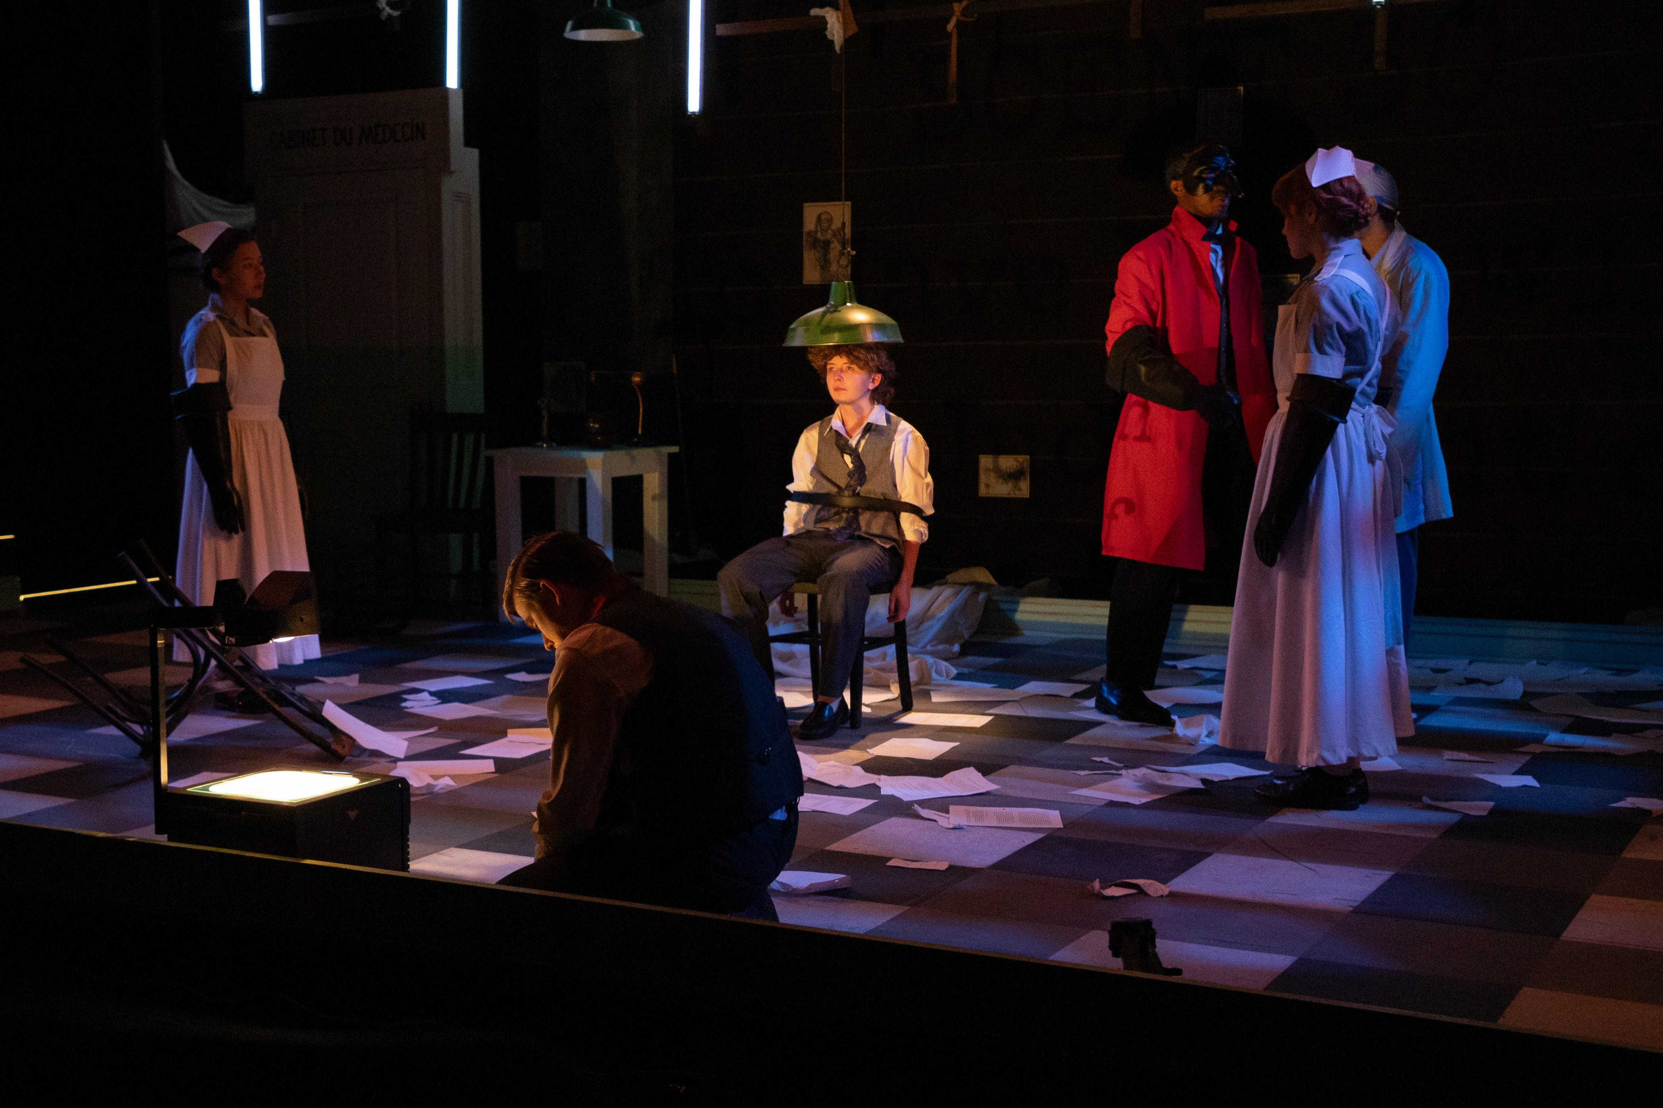
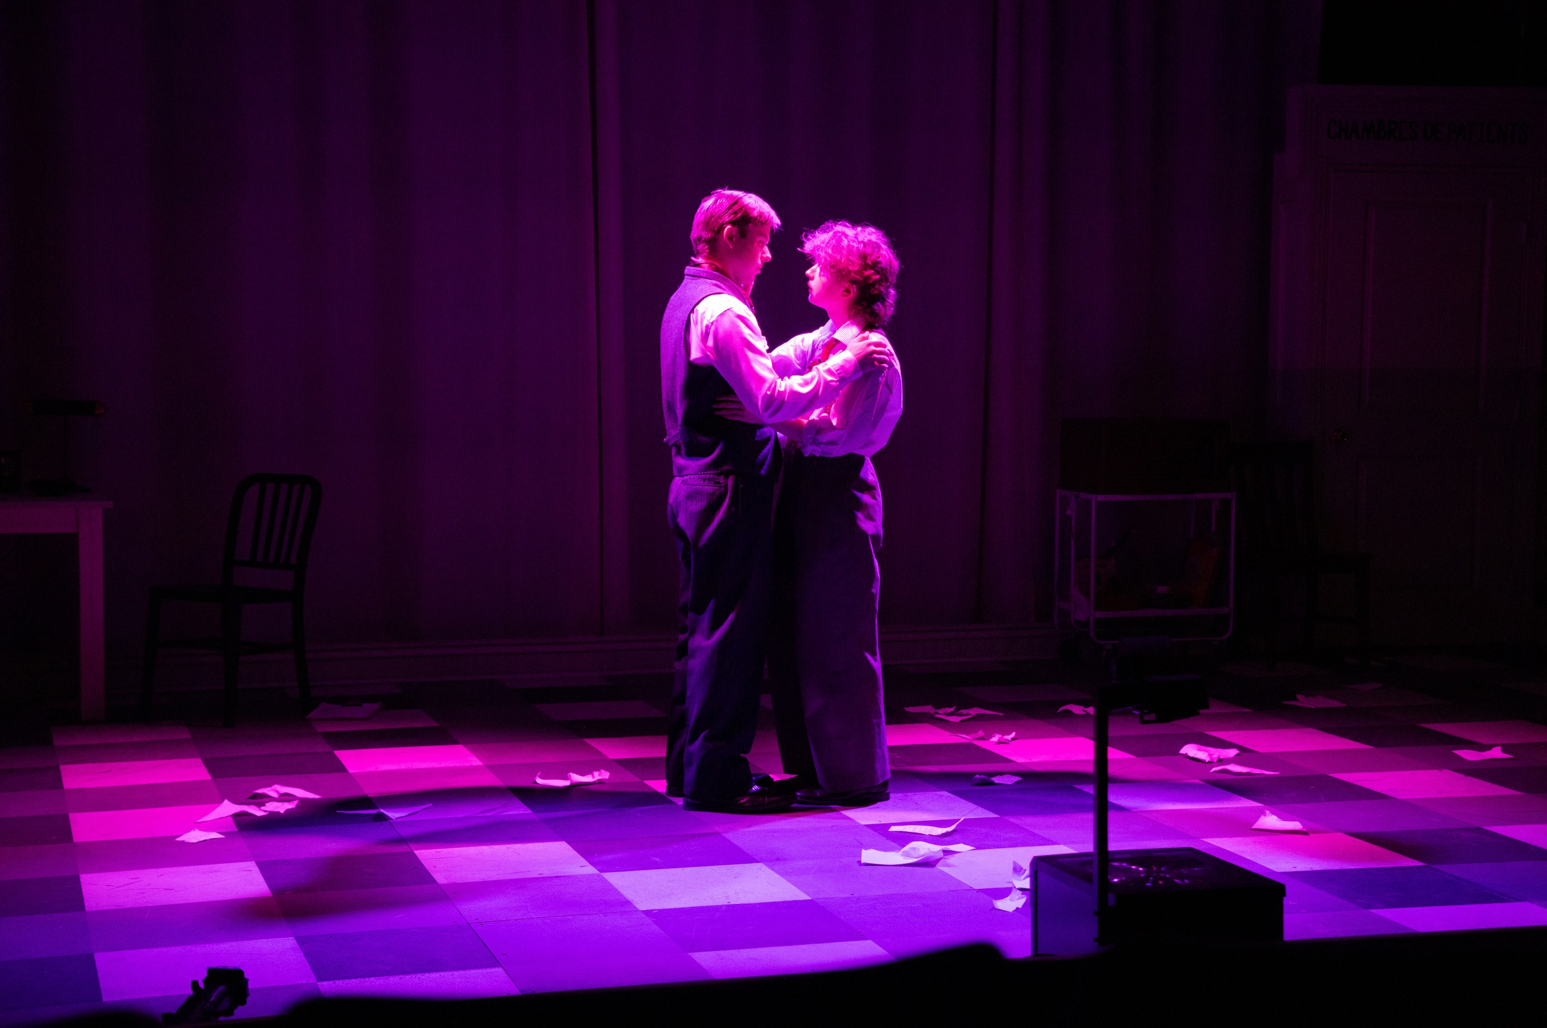
Shrek, The Musical – Asst. Lighting Designer – SUNY New Paltz

- Machadyn Theatre

